The sky

We see sun, moon and stars in the sky. These are together called heavenly bodies. The sun is star too and our earth is a planet while the moon is a natural satellite. All heavenly bodies in space called the universe.

**The Sun**

Sun is a massive ball of burning gas called a star. Sun look big because it is closer to the earth compared to other stars. The sun gives heat and light. In absence of sun, the earth would always be a dark place. The heat of the sun makes us sweat on a hot summer day. Sun warms the earth. Plants grow in sunlight, making food for animal. We should not look directly at the Sun as its strong light could damage our eyes.

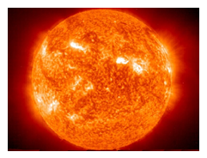

**Earth**

The earth moves around the sun in 365 days, almost a year. This movement of earth around the sun causes seasons. The earth also spins around. When earth spins, different parts of the earth have day or night. The part of the earth that does not receive light has night and part of the earth that face the sun has day.

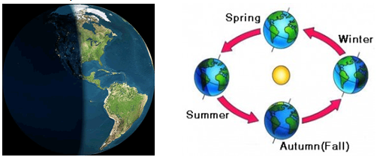

**Moon**

The moon is a big, round lump of rock that moves around the Earth. It is smaller than the earth but closer to the earth than it to the sun. It is the brightest thing we can see in the night sky. As the moon moves, the sun lights up different parts of its surface. That is why the moon shapes seems to be changing. The different moon shapes we see are phases of moon. We cannot see moon and stars in the daytime because bright light of the sun masks them.

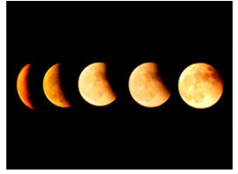

**Star**

Star has its own light. The nearest star to the earth is sun. We can see stars at night.

